SINGLE CAVITY CASE

Case overview

The experimental data base for this case was established in the wind tunnel of the University of Surrey. This data base was developed for different cavity dimensions and the experiments aimed at assessing the effect of the cavity aspect ratio on the mean flow pattern and consequently on the dispersion of pollutants within a street. The first experimental case chosen to be studied by the numerical models was that of a cavity 0.106m high and 0.212m wide. Therefore, the aspect ratio, i.e. the height of the buildings over the width of the cavity, H/W, is equal to 0.5 (Figure 1). Vertical profiles of the mean wind field (u and w components), and the turbulent kinetic energy, k, were measured upstream of the cavity and at different positions within and above the cavity.

Figure 1: Schematic representation of the cavity.

Proposed Grid

The computational grid proposed is comprised of 108×60 grid cells over the roofs, and 40×20 cells within the cavity (Figure 2). The file grid-cavity.dat contains the proposed grid. I(=1,Imax) and K(=1,Kmax) are the number of cells in the horizontal and vertical direction, respectively. x is the main flow direction and z is the vertical direction. The position x(I), z(K) corresponds to the top-right corner of the cell as shown in Figure 3.

Other special locations:
K_{roof} = 20 and corresponds to the cavity depth (z(K_{roof}) = 0.106m). I_{lee} = 7 (x(I_{lee}) = 0.0371m) corresponds to the leeward side of the cavity and I_{wind} = 47 (x(I_{wind}) = 0.2491m) to the windward side (Figure 3).

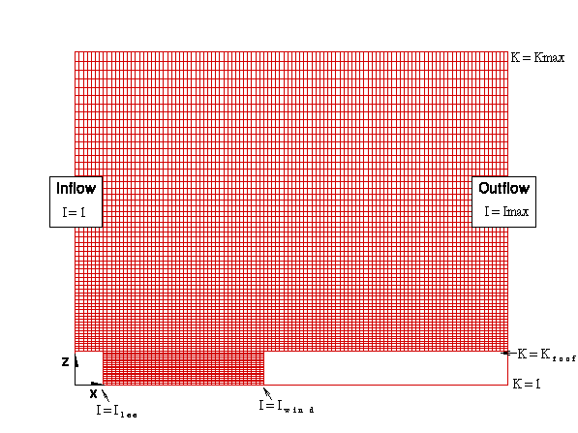
Figure 2: The proposed grid.

Figure 3: Definition of the x,z position as well as the position where u, w and k are defined.

Inflow boundary conditions

The measured vertical profiles of U, W and k at approximately 30mm upstream of the cavity were specified as the input data for the models at the inflow boundary shown in Figure 4. By computing the best fit for those profiles the following formulae, are to be used as inflow boundary conditions (I=1).

The roughness length is z₀=0.00026m and u∗=0.40 m/s. The von Karman’s constant κ=0.4.

********* 0.106m < z ≤ 0.843m **************
$$u(z)=1\text{.}\text{0776}⋅\text{ln}\left(z−0\text{.}\text{106}\right)+8\text{.}\text{1327}$$
$$v(z)=0\text{.}0$$
$$w(z)=0\text{.}0$$
$$\begin{aligned}k=0\text{.}\text{2768}{\left(z−0\text{.}\text{106}\right)}^{4}+\text{10}\text{.}\text{028}{\left(z−0\text{.}\text{106}\right)}^{3}−\text{14}\text{.}\text{431}{\left(z−0\text{.}\text{106}\right)}^{2}+ \\ 4\text{.}\text{2727}\left(z−0\text{.}\text{106}\right)+0\text{.}\text{8716}\end{aligned}$$
$$e=\frac{u_{{}^{3}}}{k\left(z−0\text{.}\text{106}\right)}$$

********* 0 ≤ z ≤ 0.106m Use k & ε as for K=K_{roof} +1 **************
$$u(z)=0\text{.}0$$
K_{roof}
K_{roof} +1
Roof-level
$$v(z)=0\text{.}0$$
$$w(z)=0\text{.}0$$
$$k(z)=k(z(K_{\text{roof}})+1)$$
$$e(z)=e(z(K_{\text{roof}})+1)$$

********* z > 0.843m Use same values as for z = 0. 843m **************
$$u(z)=u(z=0\text{.}\text{843m })$$
$$v(z)=0\text{.}0$$
$$w(z)=0\text{.}0$$
$$k(z)=k(z=0\text{.}\text{843m })$$
$$ε(z)=ε(z=0\text{.}\text{843m })$$

If using standard k-ε model the value of the constants should be:
C_{μ} = 0.09
C_{ε1} = 1.44
C_{ε2} = 1.92
σ_{k} = 1.00
σ_{ε} = 1.30
Prandtl number, Pr_{t} = 0.90
Schmidt number, Sc_{t} = 0.90

Output

Output files with vertical profiles of u, w, k and ε at horizontal positions (Figure 4):
- 20mm from the beginning of the cavity (x = 0.0571m),
- 63mm from the beginning of the cavity (x = 0.1001m),
- middle of cavity (x = 0.1431m),
- 148mm from the beginning of the cavity (x = 0.1851m), and
- 190mm from the beginning of the cavity (x = 0.2271m).

Also, horizontal distributions of u, w, k and ε at vertical positions within the cavity (Figure 4):
- z = 0.016m,
- z = 0.031m,
- z = 0.051m,
- z = 0.071m, and
- at the roof level (z = 0.106m).

The following FORTRAN lines will give the required format of the output files:

- For the vertical profiles
WRITE(10,*) 'At x = ', particular X
DO K=1,KMAX-1
WRITE(10,1)Z,U,W,TKE,EPSILON
ENDDO
- For the horizontal distributions
WRITE(11,*) 'At z = ', particular Z
DO I=ILEE+1,IWIND-1
WRITE(11,1)X,U,W,TKE,EPSILON
ENDDO

1 FORMAT(5E17.8)

Finally output files with the fields of u, w, Pressure P, k, ε, and the eddy viscosity NUT should be submitted using the following FORTRAN lines:

WRITE(12,*)'VARIABLES =X,Z,U,W,P,TKE,EPSILON,NUT'
NI=IMAX
NK=KMAX
WRITE(12,*)'I=',NI,' J=',NK
DO 10 K=1,KMAX
DO 10 I=1,IMAX
WRITE(12,*)X(I),Z(K),U(I,K),W(I,K),
$ P(I,K),TKE(I,K),EPSILON(I,K),NUT(I,K)
10 CONTINUE

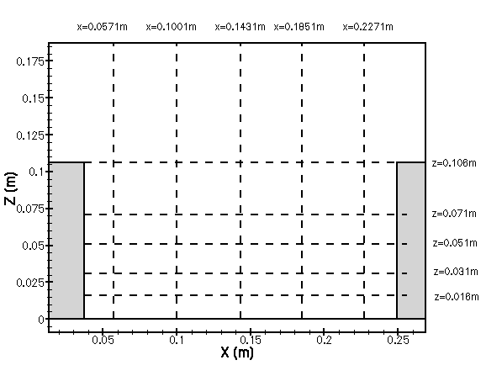
Figure 4: Horizontal and vertical positions for the output files.

For any questions or comments please contact Petroula.Louka@ec-nantes.fr

The data were provided by Drs E.Savory (e.savory@surrey.ac.uk) and A. Kovar-Panskus (A.Kovar-Panskus@surrey.ac.uk).

